# **Railway Level Crossing Gate Operation Remotely by Android**

**The project is designed to achieve control over the railway level crossing gate through Android Application by the station master. Opening and closing of railway level crossing gate involves manpower, which could be often erroneous leading to accidents.**

**Railway level crossing gate motor ,controlled by the the engine driver from a smart phone to a microcontroller through remotely operated commands to its by touch screen based user friendly GUI with Android applications for deriving an output to dive a relay for the gate motor operation.**

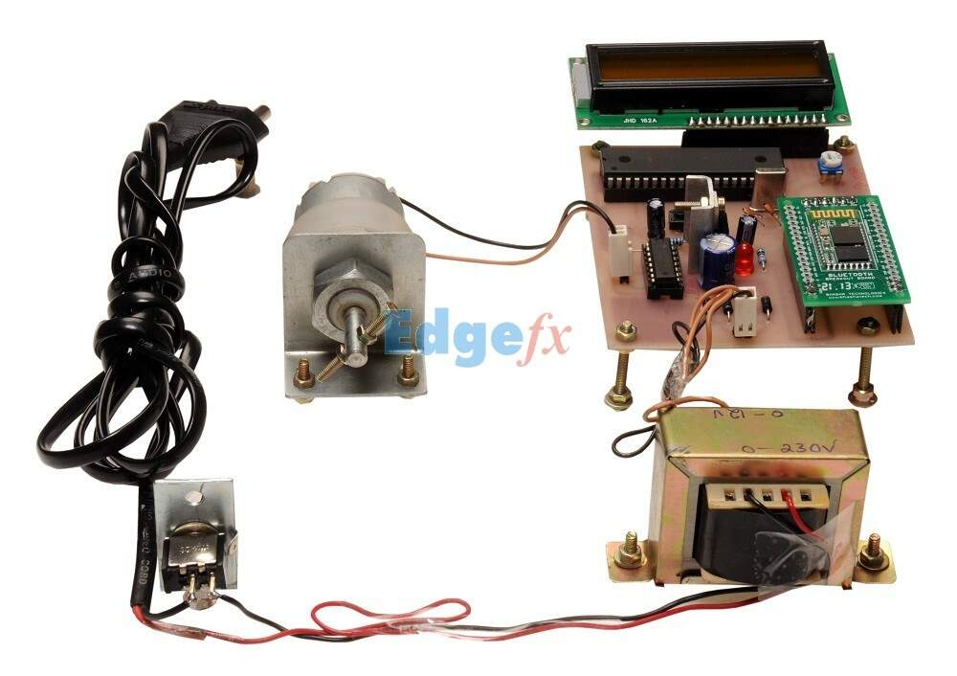

## Railway Level Crossing Gate Operation Remotely by Android

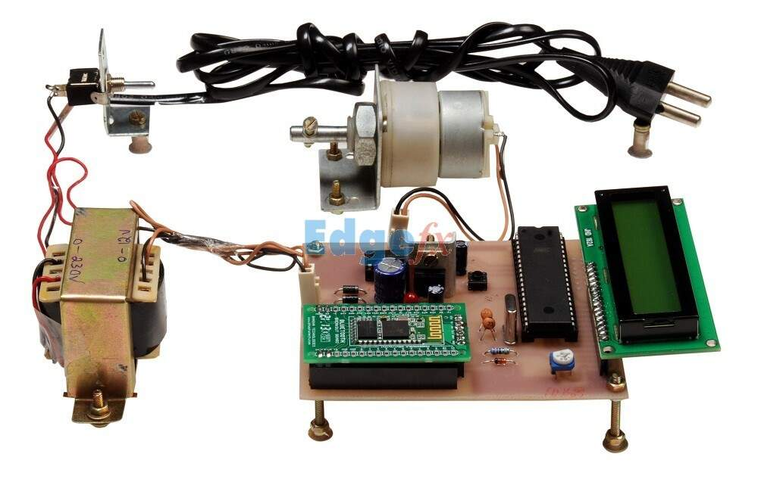

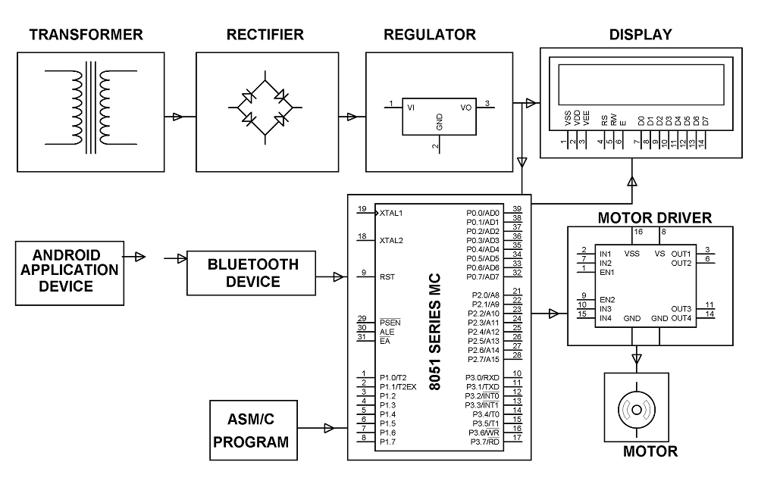

.

### Block Diagram

The project is designed to achieve control over the railway level crossing gate through Android Application by the station master. Opening and closing of railway level crossing gate involves manpower, which could be often erroneous leading to accidents. The proposed system rules out the need of any human involvement at the railway level crossing. This system involves opening and closing of the level crossing gate with help of an Android Application Device.

Remote operation is achieved by any smart-phone/Tablet etc., with Android OS, upon a GUI (Graphical User Interface) based touch screen operation. A Bluetooth device is interfaced with the system. When the station master sent command to close from the Android application device (when the train is approaching at the level crossing) to the Bluetooth device which while fed to the microcontroller, sends an output signal which activates a mechanism to switch on the motor to close the gate. To open the gate, another command needs to be sent for the microcontroller to open the gate with help of motor driver IC. In this project we use a microcontroller of 8051 family, and the input to it is a Bluetooth device which receives command from the user Android application. The output to microcontroller is given to a motor through a motor driver IC for required operation. The status, whether the gate is open / close is displayed on an LCD display interfaced to the microcontroller.

Further the project can be enhanced by sending an acknowledgement to the sender about the status of the gate.